Project Design Phase-II
Data Flow Diagram & User Stories

Date | 26-05-2025
Team ID
Project Name | E-Commerce
Maximum Marks | 4 Marks

Data Flow Diagrams:
A Data Flow Diagram (DFD) illustrates how data moves within the E-Commerce platform. It captures how users (customers, sellers and admin) interact with the system, how information flows between different components, and where the data is stored.
Example: DFD Level 0 (Industry Standard)

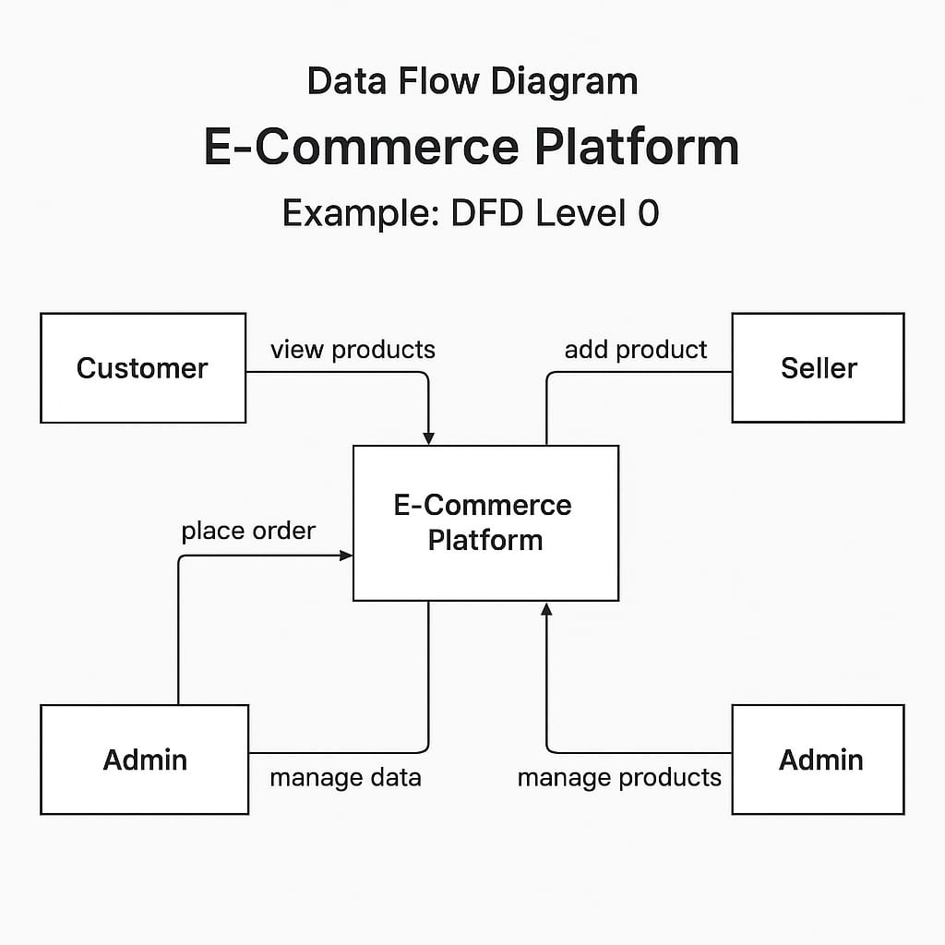

User Stories

User Story Table – E-Commerce
User Type | Functional Requirement (Epic) | User Story / Task | Acceptance Criteria | Priority | Release
Customer | Product Browsing | As a customer, I can browse and search products. | Products should display with image, price, and details. Search & filters must show correct results. | High | Sprint-1
Customer | Add to Cart | As a customer, I can add products to my cart. | Product should appear in cart with correct price, quantity & total | High | Sprint-1
Customer | Checkout | As a customer, I can place an order using my address & payment method. | Order should be successfully placed & confirmation message shown. | High | Sprint-2
Admin | Product Management | As an admin, I can add, edit & delete products. | Products must update immediately on customer side. | High | Sprint-2
Admin | Order Management | As an admin, I can view customer orders. | Orders should show customer details, order items & status. | Medium | Sprint-3
Customer | Order Tracking | As a customer, I can track my order status. | Status should update (Placed -> Shipped -> Delivered). | Medium | Sprint-3

